# VERY DEEP CONVOLUTIONAL NETWORKS FOR LARGE-SCALE IMAGE RECOGNITION

在Abstract中，VGGNET主要是根据【2】AlexNet发展而来并主要修改了以下两个方面

1. **在第一个卷基层层使用更小的filter尺寸和间隔；**

**VGG16相比AlexNet的一个改进是采用连续的几个3x3的卷积核代替AlexNet中的较大卷积核（11x11，7x7，5x5）**

1. **在整个图片和multi-scale上训练和测试图片。**

**学习参考**<https://blog.csdn.net/u014114990/article/details/50715548>

CONVNET CONFIGURATIONS

ARCHITECTURE

**where we use filters with a very small receptive field: 3 × 3**

**Filter的尺寸为3*3：**

**The convolution stride is fixed to 1 pixel;**

**卷积间隔为1**

**Use filters with 3×3 size throughout the whole net, because a stack of two 3×3 conv layers (without spatial pooling in between) has an effective receptive of 5×5, and three a stack of 3×3 conv layers has a receptive of 7×7, and so on.**

**使用3*3Filter的好处：**

1. **which is the smallest size to capture the notion of left/right, up/down,center**
2. **两个3*3的卷基层的有限感受野是5*5；三个3*3的感受野是7*7，可以替代大的filter尺寸**

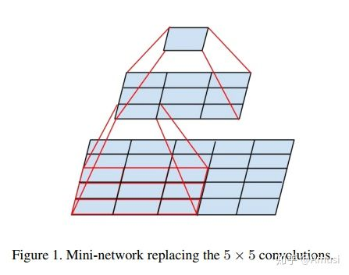

1. **多个3*3的卷基层比一个大尺寸filter卷基层有更多的非线性，使得判决函数更加具有判决性。**
2. **多个3*3的卷积层比一个大尺寸的filter有更少的参数**

8个卷基层，3个全连接层，共计11层

有5个最大池化层，5阶段卷积特征提取

CLASSIFICATION FRAMEWORK

更容易收敛的原因

**1.Implicit regularization imposed by greater depth and smaller conv filter sizes**

**2.Pre-initialisation of certain layers**

Test

总结：It was demonstrated that the representation depth is beneficial for the classification accuracy

深度有利于分类精度